**E-Commerce Website**



**Team members:**

|  |  |
| --- | --- |
| **Name** | **Role** |
| Nithin Gowd A | Product Page & Doc Work |
| Siddardha Siginam | Home Page |
| Bhavya Deepika S | Login Page |
| Joydeb Kamila | Product Page |
| Suhana Shaik | About-Us Page |
| Sampada Bhuskute | Registration Page |
| Thaslim Shaik | Cart Page & Doc Work |

# Under the guidance of

Veera Babu Yadav

**Title:**

**SHOPY**

– Your Gateway to Effortless Shopping

**Logo:**



**Introduction:**

Shopy is an innovative e-commerce platform designed to create a dynamic and engaging shopping experience for both customers and sellers. This web application is envisioned as a constantly evolving site that allows users to explore a wide range of products, make informed purchasing decisions, and engage with sellers directly. The primary objective of the project is to enable sellers to showcase their products and services while providing customers with a seamless and enjoyable shopping experience. Shopy allows sellers to list their products, manage inventory, and process orders efficiently. Customers can browse through various categories, compare products, read reviews, and make secure purchases. The platform also offers personalized recommendations, promotions, and an intuitive search feature, ensuring that every shopping journey is unique and satisfying.

Shopy also integrates advanced features like a secure payment gateway, ensuring that all transactions are safe and straightforward. The platform supports multiple payment methods, including credit cards, digital wallets, and bank transfers, catering to a diverse user base. Sellers benefit from detailed analytics and reporting tools that help them understand customer behavior, track sales, and optimize their offerings. For customers, Shopy provides a user-friendly interface that is easy to navigate, with filters and sorting options that help them find exactly what they are looking for quickly. Additionally, the platform includes a customer support system with live chat and FAQs to address any issues or queries promptly. Shopy's mobile responsiveness ensures that users can shop conveniently from any device, enhancing accessibility and expanding its reach. Whether for everyday purchases or special finds, Shopy aims to be the go-to e-commerce destination for quality, convenience, and a wide range of products.

**Abstract:**

Shopy is a cutting-edge e-commerce platform designed to offer a dynamic and user-friendly shopping experience for both customers and sellers. The platform enables sellers to efficiently list products, manage inventory, and process orders while providing customers with an intuitive interface to explore a wide variety of products, compare options, and make secure purchases. With features like personalized recommendations, advanced search capabilities, secure payment options, and robust customer support, Shopy ensures a seamless and satisfying shopping experience across all devices. By integrating detailed analytics for sellers and a mobile-responsive design, Shopy aims to become the preferred online marketplace for diverse shopping needs.

**Modules:**

Project consists of 6 modules:

1. Home Page.
2. Login Page.
3. Registration Page.
4. Products Page.
5. Cart Page.
6. About-Us Page.

**Home Page:**

The Home Page serves as the entry point to the Shopy platform, designed to be visually appealing and easy to navigate. It showcases featured products, ongoing promotions, and personalized recommendations based on user preferences and browsing history. The Home Page also includes a search bar, navigation menu, and quick links to popular categories, ensuring that users can easily find what they're looking for. This module is essential in capturing the user's attention and driving engagement with the platform.

**Login Page:**

The Login Page is where users access their personalized accounts on Shopy. This module allows both customers and sellers to securely log in using their credentials, such as email addresses, usernames, or social media accounts. For enhanced security, the Login Page includes features like password encryption, two-factor authentication, and options to reset forgotten passwords. This module ensures that user data is protected and that they can quickly and securely access their accounts.

**Registration Page:**

The Registration Page is designed for new users who want to join the Shopy community, whether as a customer or a seller. This module collects essential information such as name, email address, password, and other relevant details depending on the user type (customer or seller). It includes validation checks to ensure data accuracy and security, and provides users with terms and conditions and privacy policy agreements. The Registration Page is crucial for expanding the platform's user base and creating personalized experiences for users.

**Products Page:**

The Products Page is where users can browse and explore the wide range of products available on Shopy. This module is dynamic and organized into various categories and subcategories, with filters and sorting options to help users find products based on price, brand, ratings, and other criteria. Each product listing includes detailed descriptions, images, pricing, and customer reviews. The Products Page is the core of the shopping experience, designed to help users make informed purchasing decisions.

**Cart Page:**

The Cart Page is where users review the products they intend to purchase. This module displays the selected items, their quantities, individual prices, and the total cost, including any applicable taxes and shipping fees. Users can update quantities, remove items, or save them for later. The Cart Page also provides options to apply discount codes and proceed to checkout. This module is critical for facilitating the purchasing process, ensuring that users can easily manage their shopping before finalizing their orders.

**About-Us Page:**

The About-Us Page provides users with information about Shopy, including its mission, values, history, and team. This module is designed to build trust and credibility by sharing the story behind the platform, its goals, and its commitment to customer satisfaction. It may also include testimonials, media mentions, and links to social media profiles. The About-Us Page plays an essential role in establishing a connection with users and enhancing the brand image of Shopy.

**Analysis:**

* **Login type New User and Existing User**
* **Login Form for Existing User** 
  1. User ID field
  2. Password field
  3. Submit button

* **Registration Form for New User** 
  1. User ID field
  2. Email field
  3. Password field
  4. Confirm Password field
  5. Register Button
  6. Login here Button

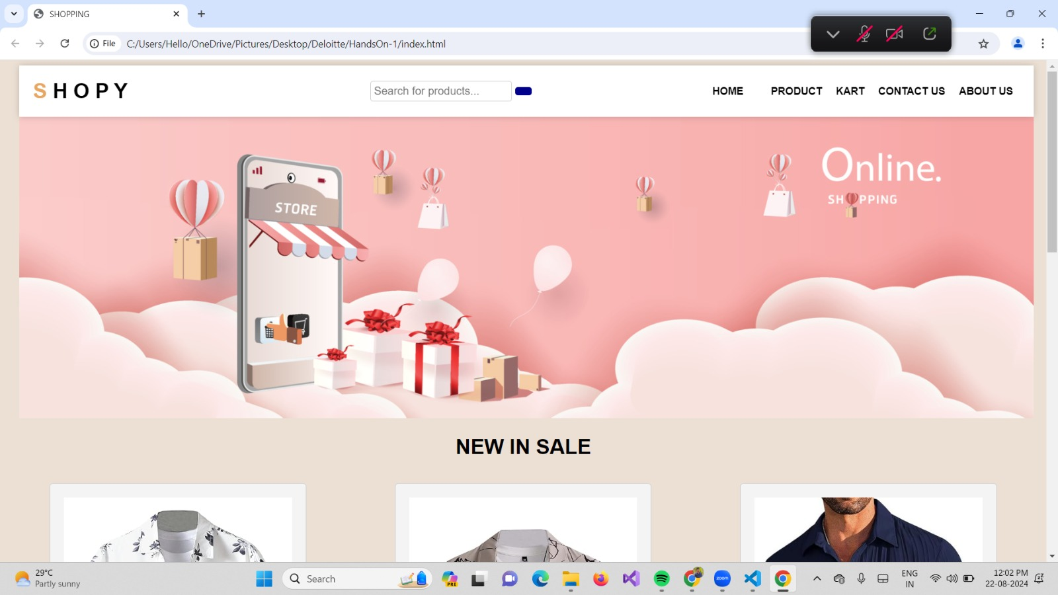**Home page:**



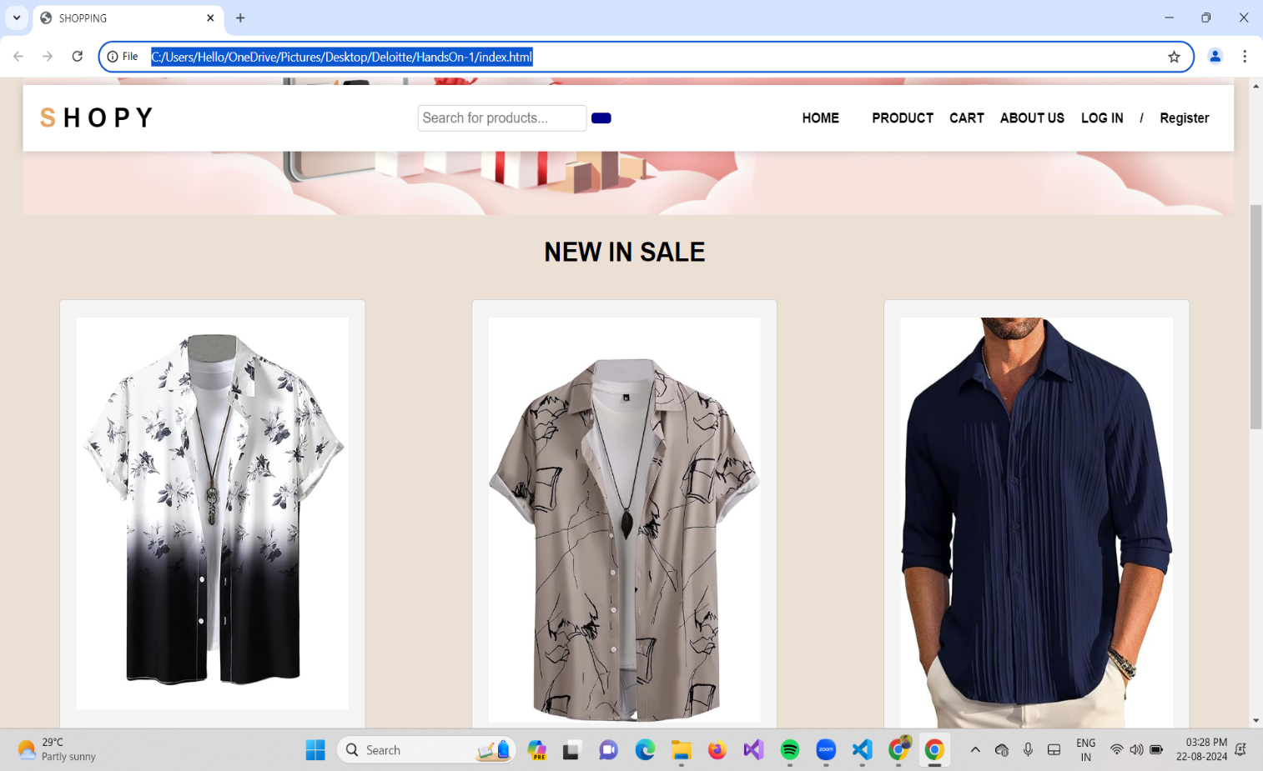

**Login page:**

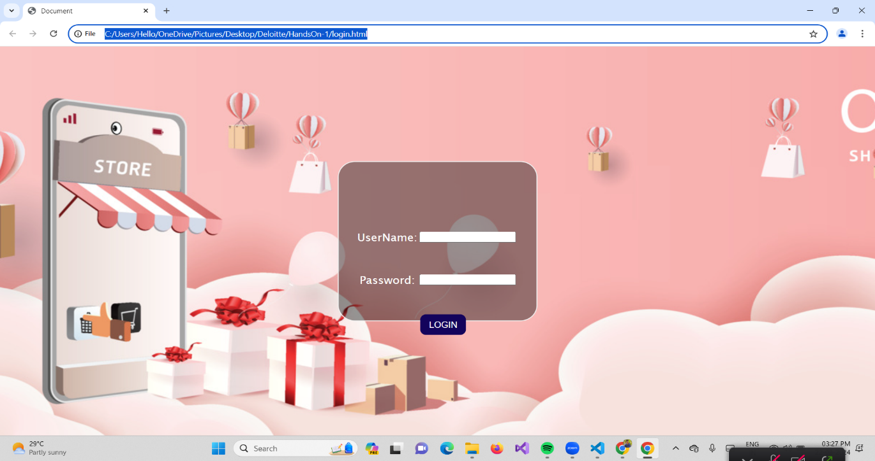

**Registration Page:**

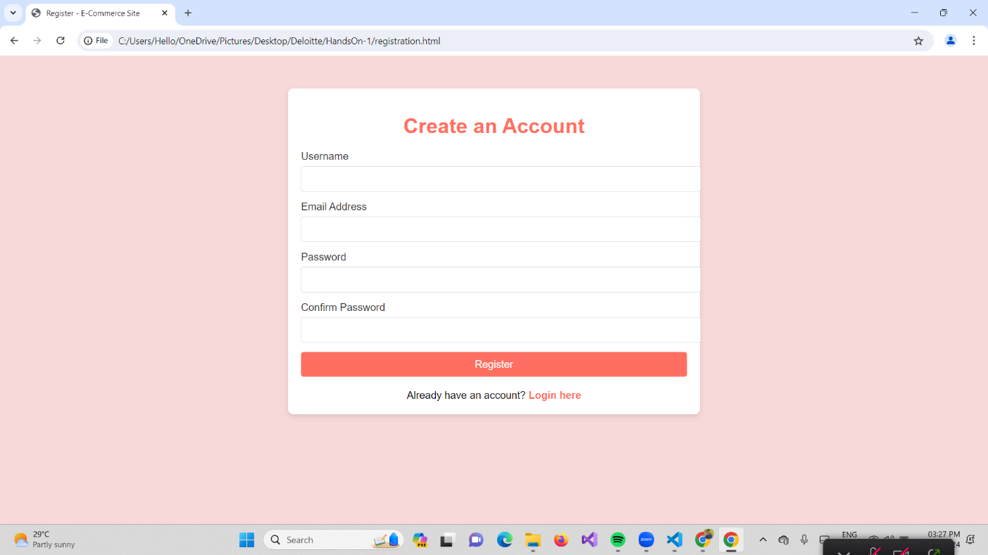

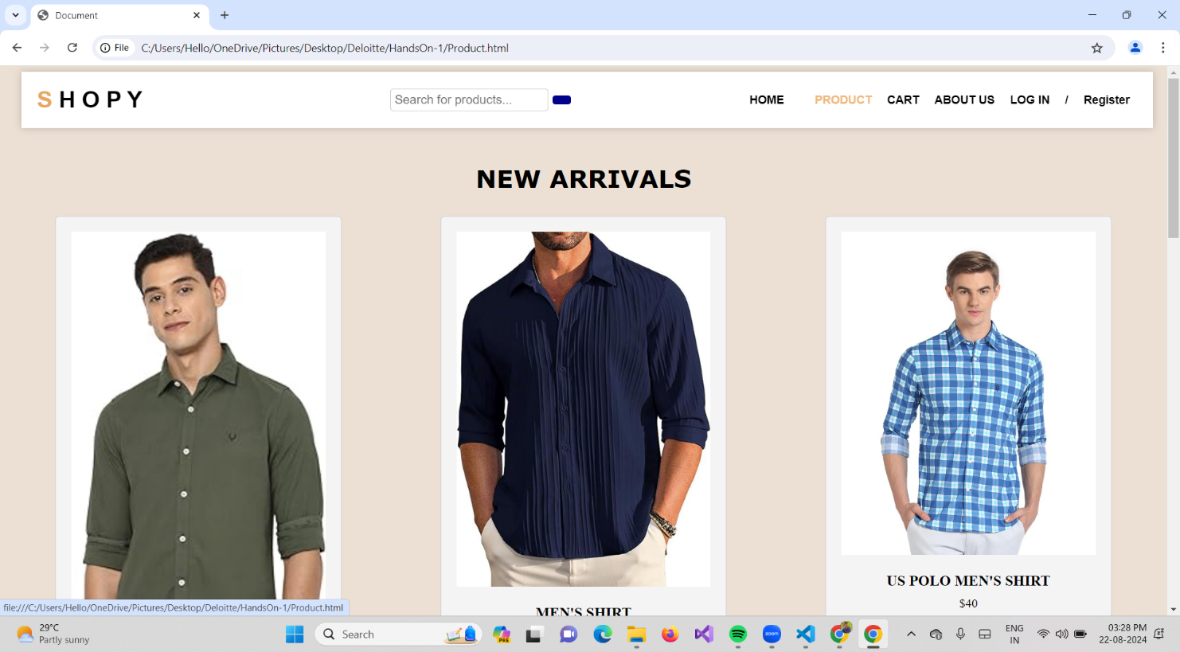**Products page:**

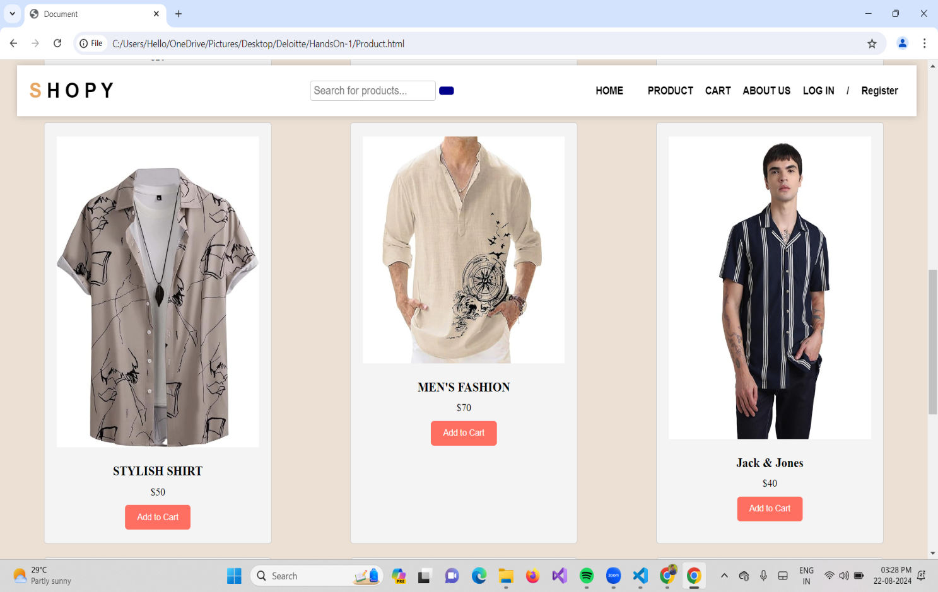

**Cart Page:**

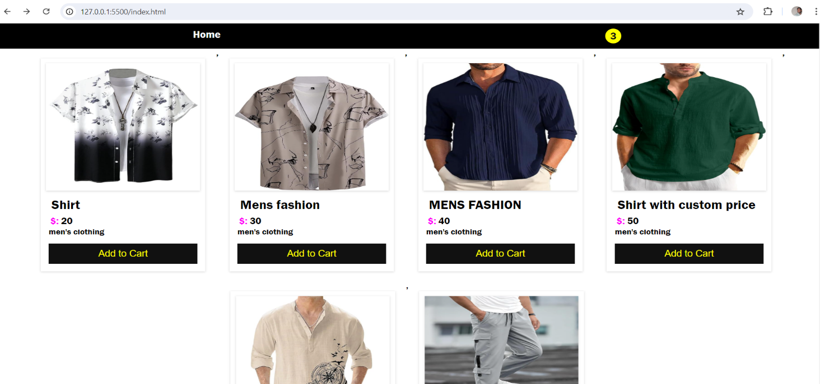

**About-Us page:**

